Practical No: 01
Title: Create web page to display name of your college, address of college and save the page with your name.
<html>
<head>
<title> My First Application </title>
</head>
<body>
<h1>College Name:SVPM's ITE Malegaon BK
<h1>College Adress: A/P Malegaon BK<br>
Tal:Baramati<br>
Dist:pune<br>
</body>
</html>
---------------------------------OUTPUT---------------------------------------
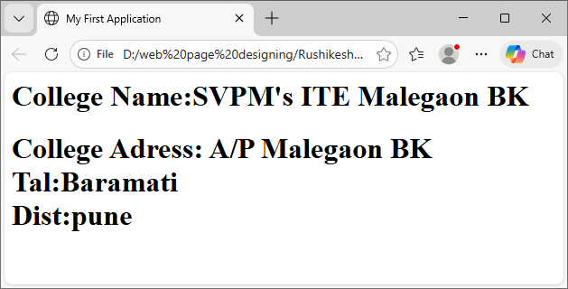

.

Practical No. 01
Title: Create a web page by using structure tags to display “Welcome to HTML World“ and apply background color as yellow and text colour as per student choice

<html>
<head>
<title> My First Application
</title>
</head>
<body bgcolor="yellow" text="red">
<h1> " Welcome to HTML World"
</body>
</html>
---------------------------------OUTPUT---------------------------------------
